**Nursing Supply and Demand Dashboard**

**Kentucky Board of Nursing**

**Published May 2024**



**Introduction**

The **Nursing Supply and Demand Dashboard** is a product of the **Kentucky Board of Nursing (KBN)**. Users have the ability to see information about nurses in four sections.

The first section, Nursing Supply, displays information around those with Kentucky Nursing Licensures. Information such as demographics and various employment metrics can be found here.

The second section, Enrollment & Grads, shows trends for enrollment, graduates, and faculty turnover by geography.

The third section, Projected Demand, shows 5-Year job projections for healthcare occupations by the Local Workforce Areas in Kentucky.

The last section, Program Map, shows prelicensure nursing programs across Kentucky.

**Section 1: Introduction**

The introduction is the landing page for this dashboard report. Descriptions are provided for each section. Users have the ability to click the Walkthrough Guide to see how dashboards are laid out, download technical documentation (this document), and an alternative, accessible, aggregate data file. A user can see which dashboard they are viewing by the alternate color on the navigation tabs to the left.

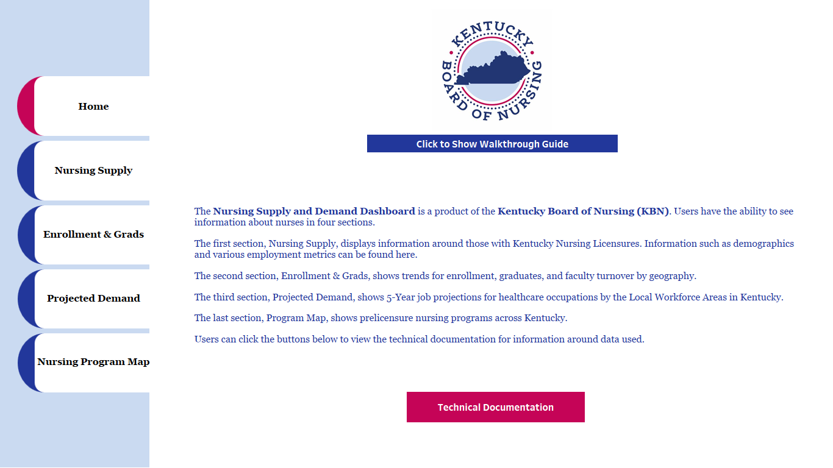

**Section 2: Nursing Supply**

This dashboard shows various metrics and demographics of nursing licensures. Users can select a Area Type (State, County, Area Development District, or Local Workforce Area) and see any region in Kentucky as well as Out-of-State/Unknown Location counts. More information about geographic regions can be found in the glossary.

The dashboard shows total licensure counts for APRN-CRNA’s, LPN’s, RN’s, and APRN’s (All Other APRN occupations), as well as breakouts by gender and race for the selected region. A grid on the right side of the dashboard can be filtered to specific employment metrics, including:

* Employment Position
* Employment Setting
* Employment Specialty
* Employment Status
* Excess Hours
* Highest Education
* Number of Positions
* Planning to Retire (in Years)
* Unemployment Reason
* Years Practiced as a Nurse

Please see the glossary for how responses were grouped into categories for each metric.

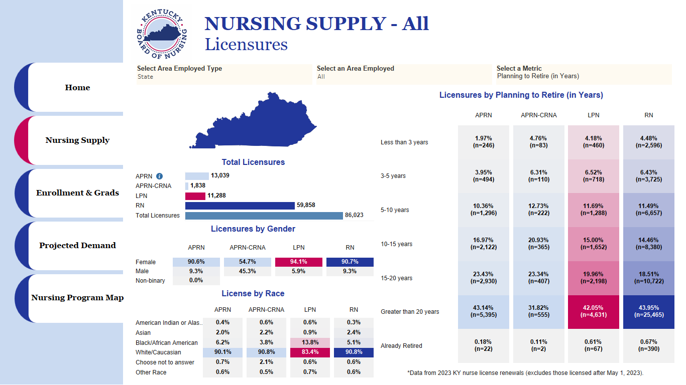

**Section 3: Enrollment & Grads**

This dashboard shows trends for prelicensure metrics. Users can select an Area Type (State, County, or Area Development District) and see any region in Kentucky. Trends and their year-over-year changes can be seen for the following metrics:

* Total Enrollment
* New Enrollment
* New Enrollment as a Percent of the Total Enrollment
* Total Graduates
* Graduation Rate
* Faculty Turnover Rate

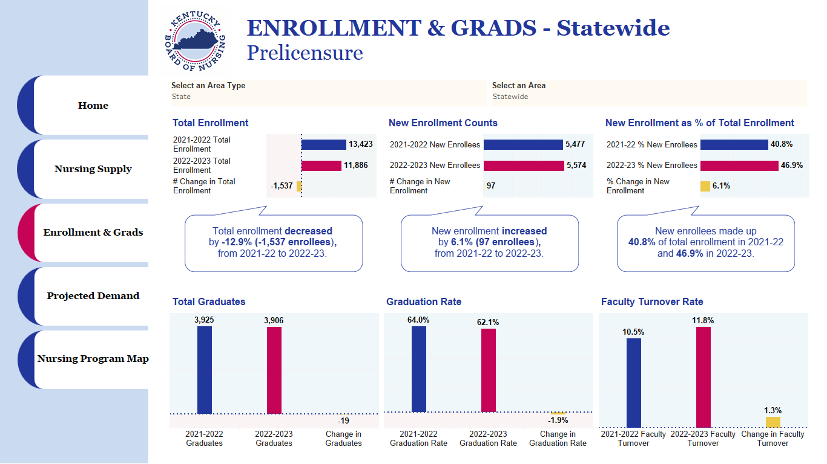

**Section 4: Projected Demand**

This dashboard shows labor market information around Licensed Practical and Licensed Vocational Nurses, Registered Nurses, and Nurse Practitioners for Kentucky and its Local Workforce Areas. Users can select an Area Type (State or Local Workforce Area). Occupational Projections are a five-year projection and provided by Kentucky’s Labor Market Information. Metrics on this dashboard include:

* Five-Year Projected Job Openings
* Five-Year Projected Change
* Five-Year Projected Exits from the workforce
* Five-Year Projected Transfers to other occupations
* 25th percentile wages
* 50th/median wages
* 75th percentile wages

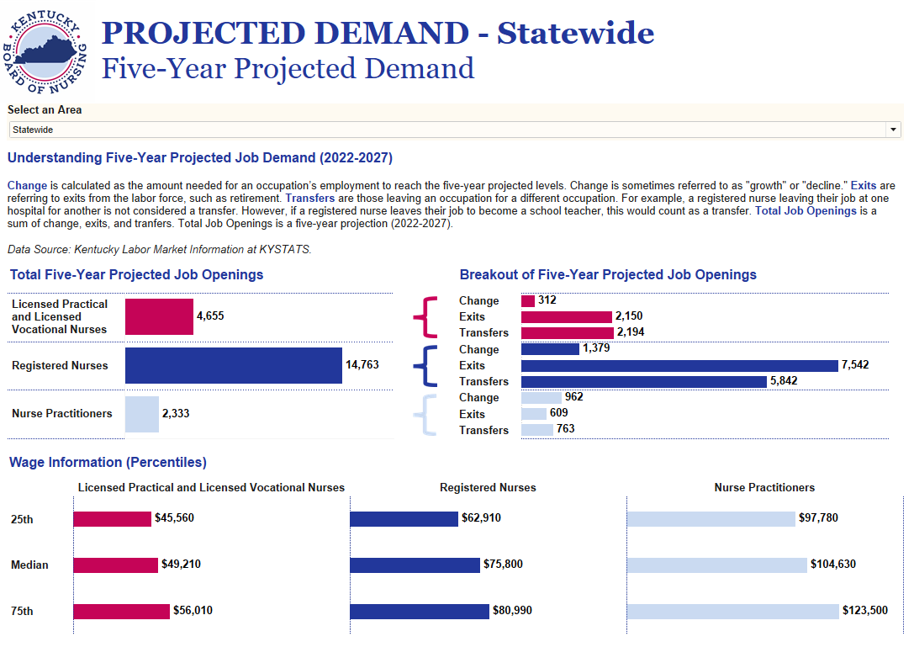

**Section 5: Program Map**

This dashboard shows a mapping tool created by the KBN showing Kentucky Prelicensure Nursing Program locations. This map shows prelicensure (RN and PN) nursing programs approved, or in the approval process, through the Kentucky Board of Nursing. Click on a program name from one of the program type headers (PN Programs, ASN Programs, BSN Programs, or MEPN Programs) or click an icon on the map to view a nursing program's address and website. You can view only a specific nursing program type by checking/unchecking the checkboxes next to the nursing program type headers. This map also lists potential clinical sites that prelicensure nursing program staff may contact to determine if the site has clinical availability that the program needs. Please be aware that KBN staff has NOT communicated with any of the Potential Clinical Sites indicated. Healthcare sites that have the possibility of being able to provide necessary clinical availability to Kentucky nursing programs have been included on this map; however, nursing program staff will have to contact the sites to determine if their clinical needs may be met by any facility listed. To view the potential clinical sites, scroll to the bottom of the list and click the checkbox next to the Potential Clinical Sites header. This map also includes information about Kentucky's Area Development Districts (ADD's) and the Kentucky Hospital Association's (KHA's) Talent Pipeline Management (TPM) Program. The KHA has partnered with the Kentucky Chamber Foundation's Workforce Center to create the TPM program, which is designed for hospitals to build talent supply chains that support career opportunities in Kentucky by recruiting talent into Kentucky hospitals and educational programs and identifying and sharing regional best practices to support critical jobs needed for various types of healthcare settings. Click on a county name under Talent Pipeline Management (TPM) header to view contact information for ADDs and TPM regions. Please be aware that this information is provided by the Kentucky Board of Nursing as a public resource, and it is not an endorsement or recommendation of any entity, program, product, or service depicted herein.

Link: [Google Maps Link](https://www.google.com/maps/d/u/0/viewer?mid=1xqTXDTO64bbGEfqtzwLSV_4oNXGwNKc&ll=38.030762560670354%2C-86.602813859375&z=7)

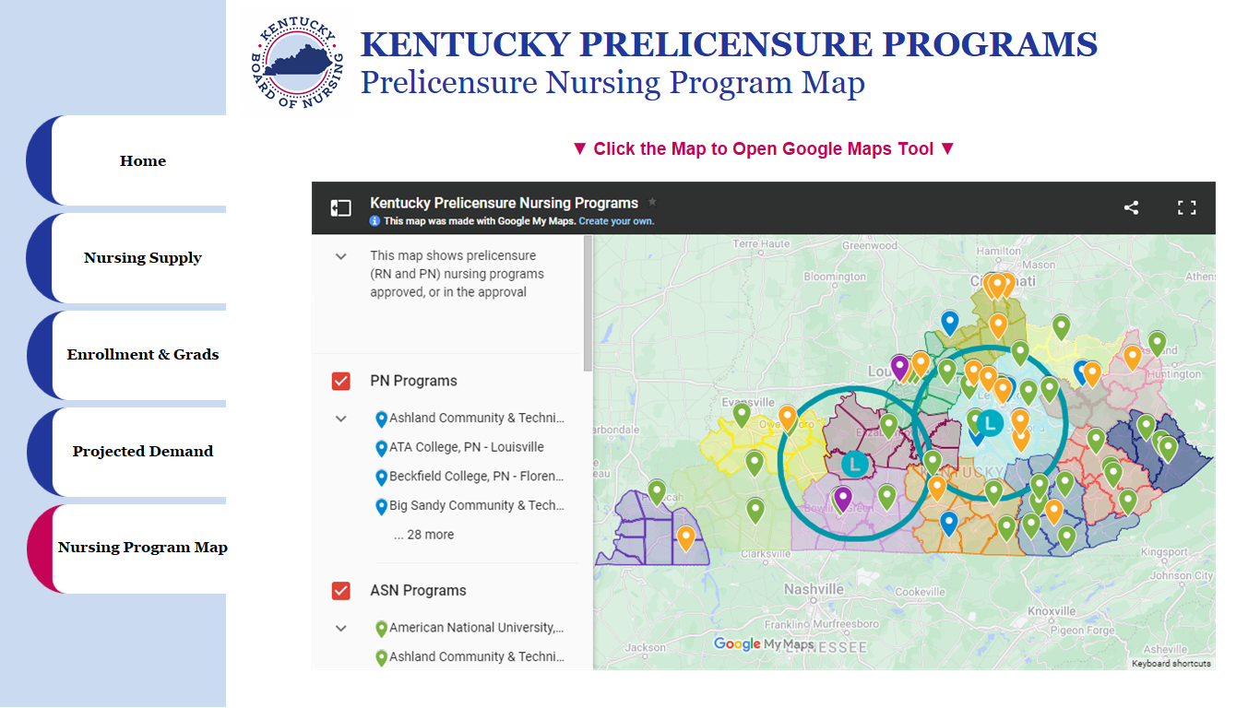

**Glossary**

**Dashboard**: Nursing Supply

**Metric**: Total Licensures

**Definition**: Total count of licensures.

**Data** **Source**: Kentucky Board of Nursing

**Elements** **Information**: Group = Total, Subgroup = All

**Dashboard**: Nursing Supply

**Metric**: Gender

**Definition**: Total Count of Licensures by their response to gender.

**Data** **Source**: Kentucky Board of Nursing

**Elements** **Information**:

|  |  |
| --- | --- |
| Gender | Female |
| Gender | Male |
| Gender | Non-binary |

**Dashboard**: Nursing Supply

**Metric**: Race

**Definition**: Total Count of Licensures by their response to race.

**Data** **Source**: Kentucky Board of Nursing

**Elements** **Information**:

|  |  |
| --- | --- |
| Race | American Indian or Alaska Native |
| Race | Asian |
| Race | Black/African American |
| Race | Choose not to answer |
| Race | Native Hawaiian or Other Pacific Islander |
| Race | Other Race |
| Race | White/Caucasian |

**Dashboard**: Nursing Supply

**Metric**: Employment Setting

**Definition**: Total Count of Licensures by their response to the setting of their employment.

**Data** **Source**: Kentucky Board of Nursing

**Elements** **Information**:

|  |  |
| --- | --- |
| Employment Setting | Ambulatory Care |
| Employment Setting | Community Health |
| Employment Setting | Government/Regulation |
| Employment Setting | Hospital |
| Employment Setting | Long-Term Care |
| Employment Setting | Mental Health/Addiction Services |
| Employment Setting | Non-Nursing/Other |
| Employment Setting | Nursing Education |
| Employment Setting | Occupational/School Health Services |
| Employment Setting | Sales/Insurance & Benefits |
| Employment Setting | Travel Nursing/Consulting |

**Dashboard**: Nursing Supply

**Metric**: Employment Position

**Definition**: Total Count of Licensures by their response to the type of position they are employed.

**Data** **Source**: Kentucky Board of Nursing

**Elements** **Information**:

|  |  |
| --- | --- |
| Employment Position | Administration |
| Employment Position | APRN |
| Employment Position | Case Manager |
| Employment Position | Development/Education |
| Employment Position | Office/Staff Nursing |
| Employment Position | Other Degree |
| Employment Position | Public Health Nursing |
| Employment Position | Quality Improvement/Assurance |
| Employment Position | School Health Nursing |
| Employment Position | Travel Nursing |

**Dashboard**: Nursing Supply

**Metric**: Employment Specialty

**Definition**: Total Count of Licensures by their response to their specialty area of employment.

**Data** **Source**: Kentucky Board of Nursing

**Elements** **Information**:

|  |  |
| --- | --- |
| Employment Specialty | Acute Care |
| Employment Specialty | Clinical/Primary Care |
| Employment Specialty | Community Health |
| Employment Specialty | Education |
| Employment Specialty | Executive/Administrative |
| Employment Specialty | Mental Health/Addiction |
| Employment Specialty | Non-Nursing |
| Employment Specialty | Quality Improvement/Assurance |
| Employment Specialty | Specialty Care |
| Employment Specialty | Surgical |

**Dashboard**: Nursing Supply

**Metric**: Employment Status

**Definition**: Total Count of Licensures by their response to their employment/unemployment status.

**Data** **Source**: Kentucky Board of Nursing

**Elements** **Information**:

|  |  |
| --- | --- |
| Employment Status | Employed in a field other than nursing Full-time |
| Employment Status | Employed in a field other than nursing on a per-diem basis |
| Employment Status | Employed in a field other than nursing Part-time |
| Employment Status | Employed in nursing or position that requires a nurse license full-time |
| Employment Status | Employed in nursing or position that requires a nurse license on a per-diem basis |
| Employment Status | Employed in nursing or position that requires a nurse license part-time |
| Employment Status | Retired from Work |
| Employment Status | Unemployed, not seeking work as a nurse |
| Employment Status | Unemployed, seeking work as a nurse |
| Employment Status | Working in nursing only as a Volunteer |

**Dashboard**: Nursing Supply

**Metric**: Excess Hours

**Definition**: Total Count of Licensures grouped by their response to on average the number of hours over 40 hours they work weekly.

**Data** **Source**: Kentucky Board of Nursing

**Elements** **Information**:

|  |  |
| --- | --- |
| Excess Hours | 4-8 hours |
| Excess Hours | 9-12 hours |
| Excess Hours | 13-16 hours |
| Excess Hours | Greater than 16 hours |
| Excess Hours | Less than 4 hours |
| Excess Hours | Retired |

**Dashboard**: Nursing Supply

**Metric**: Highest Education

**Definition**: Total Count of Licensures by their response to their highest level of educational attainment.

**Data** **Source**: Kentucky Board of Nursing

**Elements** **Information**:

|  |  |
| --- | --- |
| Highest Education | Associate Degree |
| Highest Education | Baccalaureate Degree |
| Highest Education | Diploma-Nursing (RN) |
| Highest Education | Doctoral Degree |
| Highest Education | Masters Degree |
| Highest Education | Other Degree |
| Highest Education | Post Masters Certification |
| Highest Education | Vocational/Practical Certificate-Nursing |

**Dashboard**: Nursing Supply

**Metric**: Number of Positions

**Definition**: Total Count of Licensures by their response to how many positions they currently hold.

**Data** **Source**: Kentucky Board of Nursing

**Elements** **Information**:

|  |  |
| --- | --- |
| Number of Positions | One |
| Number of Positions | Three |
| Number of Positions | Two |

**Dashboard**: Nursing Supply

**Metric**: Planning to Retire (in Years)

**Definition**: Total Count of Licensures by their response to when they plan to retire.

**Data** **Source**: Kentucky Board of Nursing

**Elements** **Information**:

|  |  |
| --- | --- |
| Planning to Retire (in Years) | 3-5 years |
| Planning to Retire (in Years) | 5-10 years |
| Planning to Retire (in Years) | 10-15 years |
| Planning to Retire (in Years) | 15-20 years |
| Planning to Retire (in Years) | Already Retired |
| Planning to Retire (in Years) | Greater than 20 years |
| Planning to Retire (in Years) | Less than 3 years |

**Dashboard**: Nursing Supply

**Metric**: Unemployment Reason

**Definition**: Total Count of Licensures by the reported reason they are unemployed.

**Data** **Source**: Kentucky Board of Nursing

**Elements** **Information**:

|  |  |
| --- | --- |
| Unemployment Reason | Benefits |
| Unemployment Reason | Difficulty in Finding a Nursing Position |
| Unemployment Reason | Disabled |
| Unemployment Reason | Inadequate Salary |
| Unemployment Reason | Lack of Resources/Support on the Job |
| Unemployment Reason | Other Reason |
| Unemployment Reason | School |
| Unemployment Reason | Stressed/Burned Out |
| Unemployment Reason | Taking Care of Home or Family |
| Unemployment Reason | Unhealthy Work Environment |

**Dashboard**: Nursing Supply

**Metric**: Years Practices as a Nurse

**Definition**: Total Count of Licensures by the number of years they have practices as a nurse.

**Data** **Source**: Kentucky Board of Nursing

**Elements** **Information**:

|  |  |
| --- | --- |
| Years Practiced as Nurse | 1-5 years |
| Years Practiced as Nurse | 6-10 years |
| Years Practiced as Nurse | 11-15 years |
| Years Practiced as Nurse | 16-20 years |
| Years Practiced as Nurse | 21-25 years |
| Years Practiced as Nurse | 26-30 years |
| Years Practiced as Nurse | Less than 1 year |
| Years Practiced as Nurse | More than 30 years |

**Dashboard**: Employment & Grads

**Metric**: Total Enrollment

**Definition**: Total count of enrollment in prelicensure programs.

**Data** **Source**:

**Elements** **Information**: 2021-2022 Total Enrollment, 2022-2023 Total Enrollment

**Dashboard**: Employment & Grads

**Metric**: # Change in Total Enrollment

**Definition**: The difference in total enrollment between 2022-2023 and 2021-22.

**Data** **Source**:

**Elements** **Information**: Calculation: 2022-2023 Total Enrollment - 2021-2022 Total Enrollment

**Dashboard**: Employment & Grads

**Metric**: New Enrollment

**Definition**: Total count of new enrollment in prelicensure programs.

**Data** **Source**:

**Elements** **Information**: 2021-2022 New Enrollees, 2022-2023 Total Enrollees

**Dashboard**: Employment & Grads

**Metric**: # Change in New Enrollment

**Definition**: The difference in new enrollment between 2022-2023 and 2021-22.

**Data** **Source**:

**Elements** **Information**: Calculation: 2022-2023 New Enrollees - 2021-2022 New Enrollees

**Dashboard**: Employment & Grads

**Metric**: New Enrollment as a % of Total Enrollment

**Definition**: Total count of new enrollment in prelicensure programs relative to the total count of enrollment.

**Data** **Source**:

**Elements** **Information**: 2021-2022 % New Enrollees, 2022-2023 % New Enrollees

**Dashboard**: Employment & Grads

**Metric**: % Change in New Enrollment

**Definition**: The difference in new enrollment as a percent of total enrollment between 2022-2023 and 2021-22.

**Data** **Source**:

**Elements** **Information**: Calculation: 2022-2023 % New Enrollees - 2021-2022 % New Enrollees

**Dashboard**: Employment & Grads

**Metric**: Total Graduates

**Definition**: Total count of graduates from prelicensure programs.

**Data** **Source**:

**Elements** **Information**: 2021-2022 Graduates, 2022-2023 Graduates

**Dashboard**: Employment & Grads

**Metric**: Change in New Enrollment

**Definition**: The difference in counts of graduates between 2022-2023 and 2021-22.

**Data** **Source**:

**Elements** **Information**: Calculation: 2022-2023 Graduates - 2021-2022 Graduates

**Dashboard**: Employment & Grads

**Metric**: Graduation Rate

**Definition**: The graduation rate from prelicensure programs.

**Data** **Source**:

**Elements** **Information**: 2021-2022 Graduation Rate, 2022-2023 Graduation Rate

**Dashboard**: Employment & Grads

**Metric**: Change in Graduation Rate

**Definition**: The difference in graduation rates between 2022-2023 and 2021-22.

**Data** **Source**:

**Elements** **Information**: Calculation: 2022-2023 Graduation Rate - 2021-2022 Graduation Rate

**Metric**: Faculty Turnover Rate

**Definition**: The rate at which faculty exit from prelicensure programs.

**Data** **Source**:

**Elements** **Information**: 2021-2022 Faculty Turnover Rate, 2022-2023 Faculty Turnover Rate

**Dashboard**: Employment & Grads

**Metric**: Change in Faculty Turnover Rate

**Definition**: The difference in Faculty Turnover rates between 2022-2023 and 2021-22.

**Data** **Source**:

**Elements** **Information**: Calculation: 2022-2023 Faculty Turnover Rate - 2021-2022 Faculty Turnover Rate

**Dashboard**: Projected Demand

**Metric**: Job Openings

**Definition**: A sum of change in employment, exits from the workforce such as retirement, and transfers from one occupation to a different occupation.

**Data** **Source**: Kentucky Labor Market Information, KYSTATS

**Elements** **Information**: Calculation: Change + Exits + Transfers

**Dashboard**: Projected Demand

**Metric**: Change

**Definition**: The amount needed for an occupation’s employment to reach five-year projected levels (sometimes referred to as growth or decline).

**Data** **Source**: Kentucky Labor Market Information, KYSTATS

**Elements** **Information**: Change

**Dashboard**: Projected Demand

**Metric**: Exits

**Definition**: Those leaving the labor force (e.g. retirement).

**Data** **Source**: Kentucky Labor Market Information, KYSTATS

**Elements** **Information**: Exits

**Dashboard**: Projected Demand

**Metric**: Transfers

**Definition**: Those leaving an occupation for a different occupation (e.g. a Registered Nurse leaving to become a school teacher).

**Data** **Source**: Kentucky Labor Market Information, KYSTATS

**Elements** **Information:** Transfers

**Dashboard**: Projected Demand

**Metric**: Wage Information

**Definition**: Wages for each occupation collected from data from Labor Market Information.

**Data** **Source**: Kentucky Labor Market Information, KYSTATS

**Elements** **Information:** 25th Percentile, Median (50th), 75th Percentile